Title Goes Here (Capitalize the First Letter of Major Words; do not use all Capital Letters)

First Author¹, Second Author¹, Third Author²

¹Affiliation, City, State,
²Additional Affiliation (if needed), City, State
Primary Author Email Address

[Placeholder for Digital Object Identifier (DOI) to be added - remove this wording but leave space]

TECHNICAL ABSTRACT
This should be an updated version from the RTE proposal.

PROJECT DESCRIPTION
This should be an updated version of the description from the RTE proposal.

All tables and figures should be mentioned in the text. Please include a Table 1 that lists the NSUF facilities utilized and a Table II that covers the specimens/materials and the activities performed. Add data tables as needed.

Table I. NSUF Partner Facilities Utilized [example data]

Facility | Activity
INL/Electron Microscopy Lab | Sample preparation
Michigan Ion Beam Lab | Irradiation
CAES MaCS Lab | Post-Irradiation Examination

Table II. Specimen Materials and Activities [example data]

Materials | Sample ID | Irradiation cycles | FIB for APT sample preparation | Acquisition of APT data
SRA ZIRLO | XL42 | 1 | √ | √
SRA ZIRLO | X4 | 3 | √ | √
RXA X2 | N42 | 4 | √ | √
RXA X2 | N43 | 1 | √ | √

RESULTS

List the preliminary research results, at this point, and discuss the significance. You can restate your hypothesis, if you like. Please note that this will be published on the NSUF website as soon as it is reviewed, so do not include any data or conclusions that you don’t want to be made public yet.

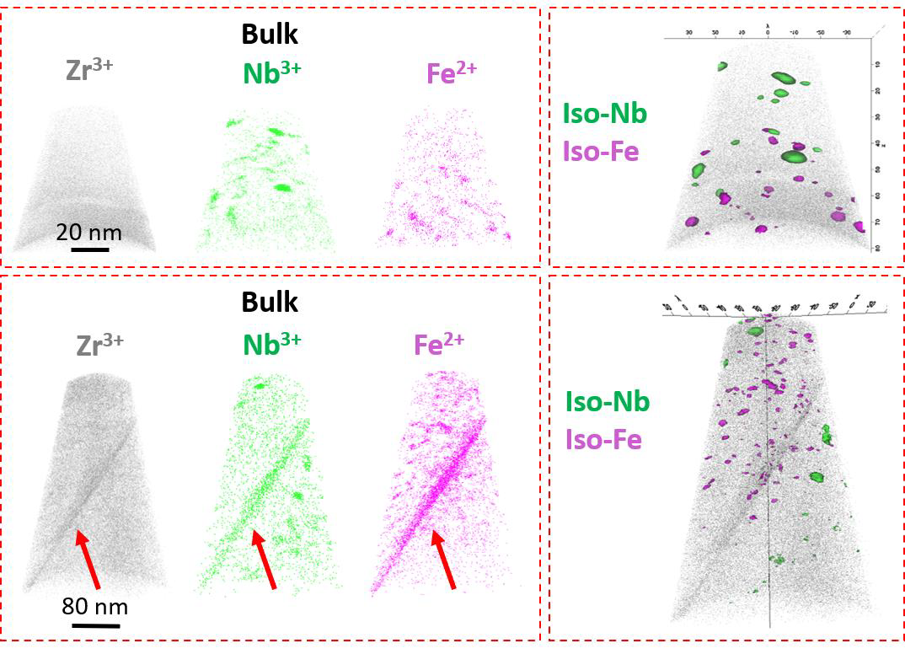
Fig. 1. [EXAMPLE] 3D reconstruction of two APT tips in the metal matrix of 4 cycles X2®. Red arrows point to the grain boundary that Nb and Fe have segregated to. The two APT tips locate at about 1-1.5 μm below the O/M interface.

Table III. Specimen Data [example data]

Materials | Sample ID | Data…
SRA ZIRLO | XL42
SRA ZIRLO | X4
RXA X2 | N42
RXA X2 | N43

PUBLICATIONS AND PRESENTATIONS

Planned and pending presentations and publications from this project

PROGRAM RELEVANCE

This can be the statement from the RTE proposal

Impact

This can be a description of the potential impact to the state-of-knowledge.

REFERENCES (All references should be cited in the text in numerical order, in order of appearance. If the source is not cited in the text, it should not appear in the list below.)

[example] 1. J. Gleason, “Format for a Report,” ANS-2008, American Nuclear Society (2008).

OTHER FORMATTING NOTES:
- Summaries must be submitted as Microsoft Word *.docx format.
- The completion report should be two to four pages, including references, tables, and figures.
- Limit the title to ten words: limit listing authors to three or fewer if possible.
- Do not use all capital letters for the title or any part of the authors’ names. For the title of the summary, Capitalize
- the First Letter of Major Words. Author names should be First Name or Initial(s) followed by Last Name.
- Do not use page numbers, headers, highlighting, or footers.
- Keep the bottom margin clear so there is space for the footer and page number.

